COSC2299

Software Requirements Specification Document

Project: EventHub – Campus Event Management System
Version 1.0
Date: 04/08/2025

Milestone 1
Group: P04-02
Group Members:
- Yunie Cho (s4001725)
- Zac Spongberg (s4096726)
- Agampreet Singh (s4014941)
- Lucas Aponso (s3896348)

Table of Contents

1. Introduction 2
1.1 Purpose 3
1.2 Scope 3
1.3 Stakeholders 3
2. Functional Requirements 3
2.1 Event Management 3
2.2 User Participation 3
2.3 Event Recommendations 3
2.4 Event Gallery 4
2.5 Admin Tools 4
2.6 Extension Features 4
2.7 Custom Features 4
3. Non-Functional Requirements 4
4. System Architecture 4
4.1 Overview 5
4.2 Architectural Diagram 5
5. User Interface Design 5
5.1 Pages and Components 5
5.2 UI Tools 5
6. Assumptions and Constraints 5
6.1 Assumptions 6
6.2 Constraints 6
7. Dependencies 6
8. Glossary 6

Introduction

< Provides an overview of the project, its purpose, and stakeholders.>

1.1 Purpose
EventHub’s purpose is to provide a user-friendly web platform that streamlines the management and participation of university events for both students and organizers. It allows university clubs and student organizers to create, publish, and manage events. Students can browse upcoming events, RSVP, and get reminders, and club organizers can track attendance of events and gather feedback from users.

1.2 Scope
EventHub will be developed as a responsive web application accessible to university students, club organizers, and administrators. The key modules include:
Event Management: Creating, editing, viewing, and deleting events.
User Participation: RSVP functionality, attendance tracking, and event sharing. //feedback
Event Recommendations: Personalized event suggestions based on user behavior and interests.
Gallery Features: Post-event media uploads for public viewing.
Administrative Controls: User management and content moderation.
The platform will integrate with campus data and support user authentication and session management. It is based on a relational database that contains event and club management, comparison, and recommendation functions, as well as the ability to notify users about relevant events, clubs, or payments.

1.3 Stakeholders
Our stakeholders include:
- Students: End users attending the events
- Club organizers: Users creating and managing events.
- System Admins: Moderators overseeing system operations.
- Product Owner: Tutor (Dale) as the client

Functional Requirements
< Describes the application's features and functionalities.>

2.1 Event Management

2.2 Event Creation
- FR-001: The system shall allow organizers to create new events with the following compulsory fields:
  - Event title (text field, max 200 characters)
  - Event description (rich text editor, max 2000 characters)
  - Date and Time (date/time picker with validation for future dates)
  - Location (text field with Google Maps API)
  - Category (dropdown selection from predefined categories)
  - Keyword/tags (multi-select from predefined tags)
- FR-002: The system shall validate event data to ensure all required fields are completed before event submission
- FR-003: The system shall automatically assign the logged-in user as the event organizer upon creation
- FR-004: The system shall generate unique event ID upon successful creation.

2.2 Event Modification
- FR-005: The system shall allow event organizers to modify event details except event ID
- FR-006: System shall notify all RSVP’d users of significant changes (date, time, location) //TODO need a definition for notify in the glossary
- FR-006: System shall provide organizers the ability to delete events
- FR-007: System shall provide confirmation dialog prior to deletion of events
- FR-008: System shall restrict edit/delete permissions to original organizer only

2.3 Event Display and Discovery
- FR-009: Home page shall display upcoming events in chronological order (next 5 or 10 upcoming events) with an option to view more
- FR-010: System shall provide detailed event listing including:
  - Event title
  - Date and Time
  - Location
  - Event description

2.2 User Participation
- FR-011: The system shall allow logged-in users to RSVP to any upcoming event by clicking an RSVP button on the event detail page.
- FR-012: The system shall prevent duplicate RSVPs from the same user for the same event.
- FR-013: The system shall allow users to cancel their RSVP at any time before the event's scheduled start.
- FR-014: The system shall provide users with a personalized dashboard that displays a list of all upcoming events they have RSVP’d to.
- FR-015: The system shall allow users to receive automated reminders (via email or in-app notification) at a user-specified time before an event they have RSVP’d to.
- FR-016: The system shall allow organizers to view a list of users who have RSVP’d to their events from the organizer dashboard.
- FR-017: The system shall restrict RSVP functionality to authenticated users only.
//privacy requirement?

2.3 Event Recommendations
- FR-018: The system shall generate event recommendations for each logged-in user on the home page or dashboard.
- FR-019: The system shall recommend events based on the categories and tags of events the user has previously RSVP’d to.
- FR-020: The system shall recommend events organized by clubs the user has joined or interacted with.
- FR-021: The system shall identify similar users based on overlapping RSVP history and recommend events those users have RSVP’d to.
- FR-022: The system shall display recommended events in a separate "Recommended for You" section, limited to a maximum of 5 events at a time.
- FR-023: The system shall update event recommendations dynamically whenever the user RSVPs to a new event or joins a new club.
- FR-024: The system shall exclude events the user has already RSVP’d to or events that have already occurred from the recommendation list.
//LMK if this is too ambitious -zac

2.4 Event Gallery

2.5 Admin Tools

2.6 Extension Features

2.7 Custom Features

Non-Functional Requirements

< Covers aspects like performance, security, usability, and reliability.>
- Performance: System can handle hundreds of concurrent users.
- Security: JWT-based authentication, role-based authentication
- Portability: Deployable via Docker on the cloud

System Architecture

< Presents a high-level architectural diagram and explains the system components and their interactions. >

4.1 Overview
The system follows an MVC structure.
It uses various technologies like -
- Backend: Java 17, SpringBoot (Rest API)
- Frontend: React, TailwindCSS
- Database: MySQL
- Build Tool: Maven, Vite
- Containerization: Docker
- CI/CD: GitHub Actions

4.2 Architectural Diagram
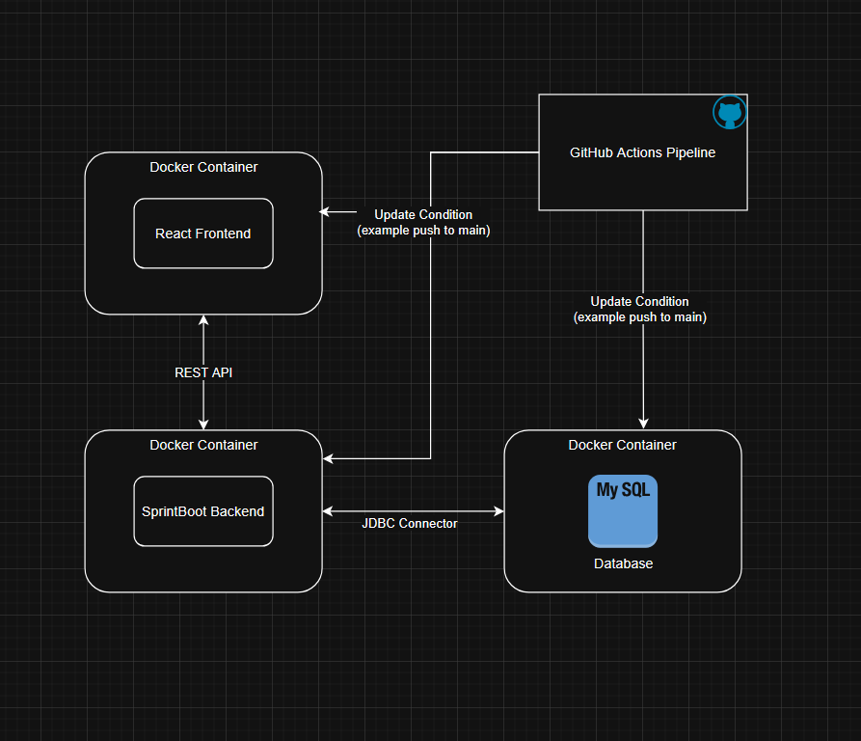

User Interface Design
< Outlines the application's visual and interactive elements.>

5.1 Pages and Components

5.2 UI Tools

Assumptions and Constraints
< States any assumptions made during requirement gathering and any constraints that may affect the project.>

6.1 Assumptions
- Users have RMIT credentials

6.2 Constraints
- Application must use SpringBoot and MySQL
- Must be deployable via Docker
- Must adhere to Agile Methodology

7. Dependencies
< Identifies external systems, libraries, or APIs required for the application.>

8. Glossary
< Provides a list of terms and definitions used in the document.>
- RSVP: A user indication of attendance
- EventHub: Name of the event management application
- MVC: Model-View-Controller
- JWT: JSON Web Token
- REST API: Representational State Transfer Application Programming Interface

